What does the Parent Liaison do?

- Reviews daily Attendance Log
- Contacts parents of all absent students
- Transports students in emergency situations under the direction of the administration
- Provides transportation to parents for school meetings with school personnel
- Advocates for families at Attendance Review Team meetings, if needed

A student risks loss of credit in a course whenever the following limits are exceeded in the course:

Length of Course | No. UNX Absences
1 Quarter | 8
Semester | 16

We are here to work with you to make every child as successful as possible.

Bug-O-Nay-Ge-Shig
Middle School/High School Attendance Program

For Truancy/Attendance Concerns, please contact:
Julie Gordon
Bug-O-Nay-Ge-Shig School
15353 Silver Eagle Drive NW
Bena, MN 56626
Phone (218) 665-3000 ext. 2215
Toll-Free (800) 265-5576
Fax (218) 665-3024
Email jugordon@bugschool.k12.mn.us

Website www.bugonaygeshig.org
*If your child is absent, please call the school or send in a note immediately upon return.

All enrolled Bug-O-Nay-Ge-Shig students are expected to attend school every day on time, unless lawfully excused by the school. The students are subject to Compulsory Attendance, Leech Lake Band of Ojibwe Judicial Code Title 4: Juvenile Justice Code (2010)

School Wide attendance goal:
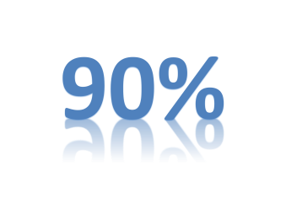

School Hours:
Teachers are on duty at 7:45 a.m., children should not arrive earlier than 8:00 a.m. Instructional Hours are from 8:35 a.m. to 3:15 p.m. Early release days are scheduled from 8:35 a.m. to 1:31 p.m.

Attendance is taken hourly for each scheduled class. Students arriving after the bell will be marked Tardy. Students more than 5 minutes late to class must obtain an Admit Ticket to be admitted to class, or will be marked as Unexcused. Leaving class before the bell is considered Skipping.

Attendance Consequences:

